Project Report
Yang Xiaoyao 24104918d
- Summary of design and implementation
- Multi-threading
The main thread listens on 127.0.0.1:8080. For each connection, it spawns a new daemon thread to handle all HTTP requests on that connection. This enables multiple clients to access the server without blocking each other.
Use "print(f"[THREAD] Handling {client_addr} in thread {threading.current_thread().name}")" to indicate the multi threads in each different clients.
- Proper request and response
First, all MIME types are supported for file extension. On HTTP request parsing, the program follows the standard form of HTTP respond and print it out. The default page will map to /index.html automatically.
According to the requirements, the server only supports GET and HEAD request types, it will return "200 OK", whereas "400 Bad Request" on other request types; the program rejects paths containing .. or /../ to prevent directory traversal, the program should return "403 Forbidden" and [DEBUG] filename before security; if the file does not exist, return "404 Not Found"; if the request contains If-Modified-Since and the file’s modified time <= the value, return "304 Not Modified" and [DEBUG] client_time and stat.st_mtime for cache validation. All of wrong messages are sent by send_error_response(), except 304 Not Modified.
The response part will call response_headers() to generate standard headers, including status line, Date, Server, Last-Modified, ETag, Accept-Ranges, Content-Type, Content-Length, Connection, Keep-Alive.
For persistent connections which are based on the client’s Connection header, it decides whether to keep the connection alive. If keep-alive is requested, stay in the loop to handle subsequent requests on the same socket.
- Log record
The thread-safe lock ensures that each request is recorded in server.log with the format: client_ip - - [timestamp] "requested_file" status_code. Logs are also printed to the console.

- Demonstration with screen capturing
- Multi-threading, Get requests for both text file and image file, Head request
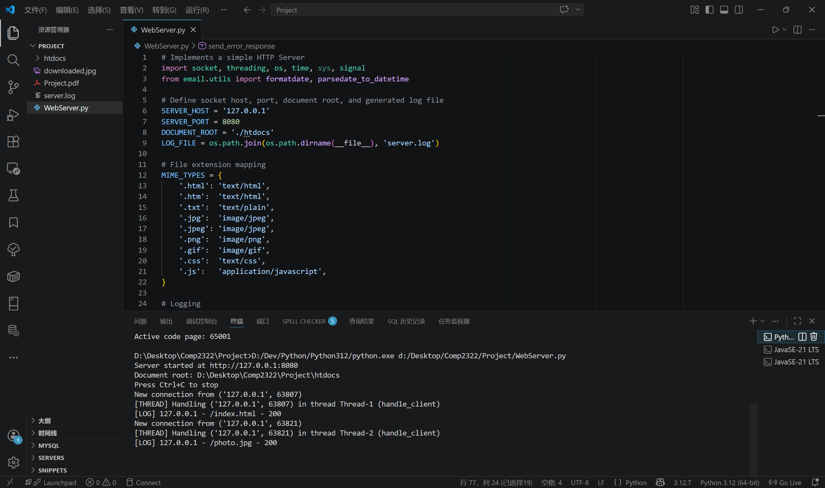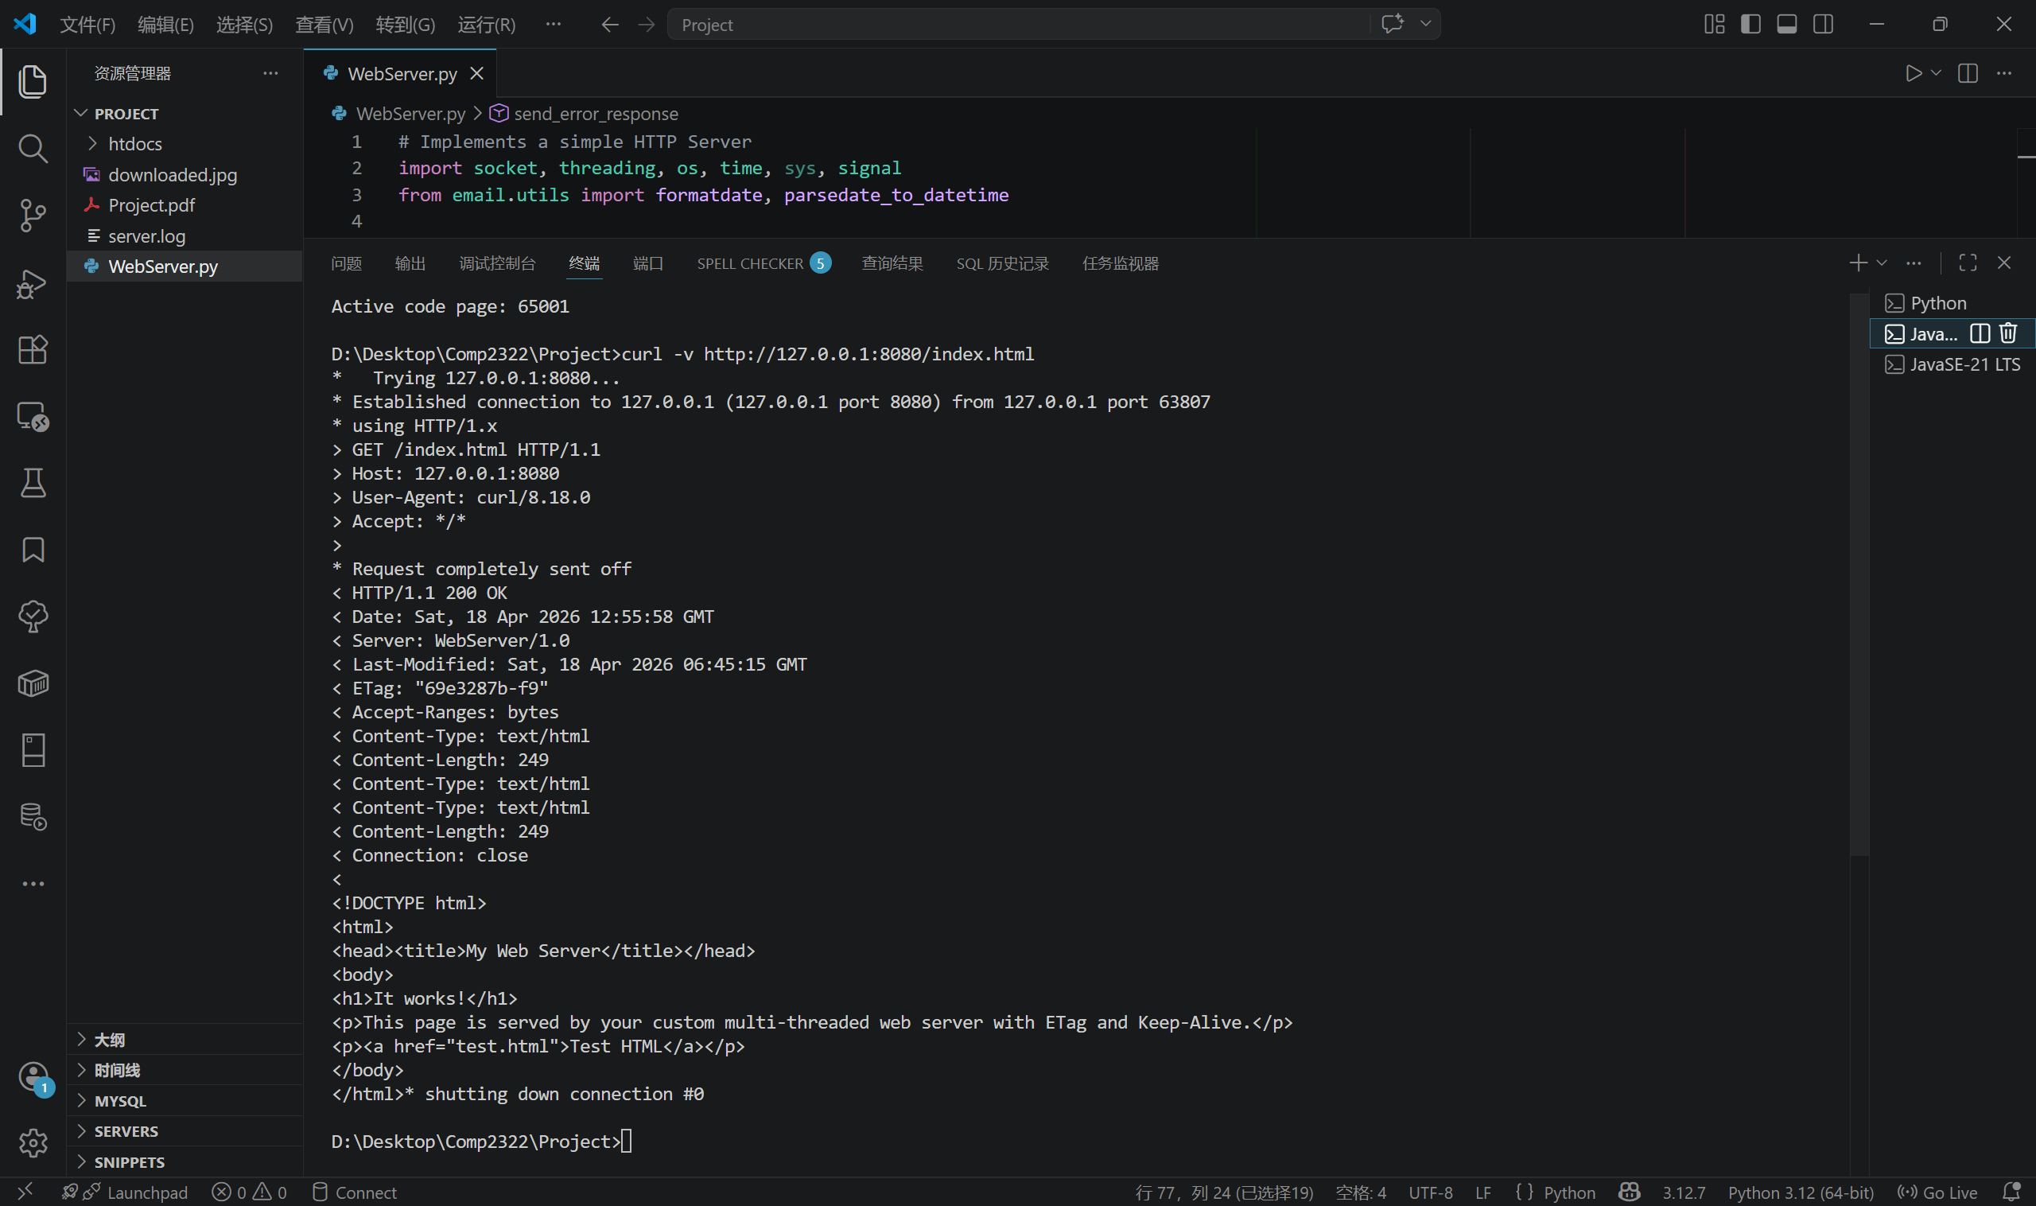
Text files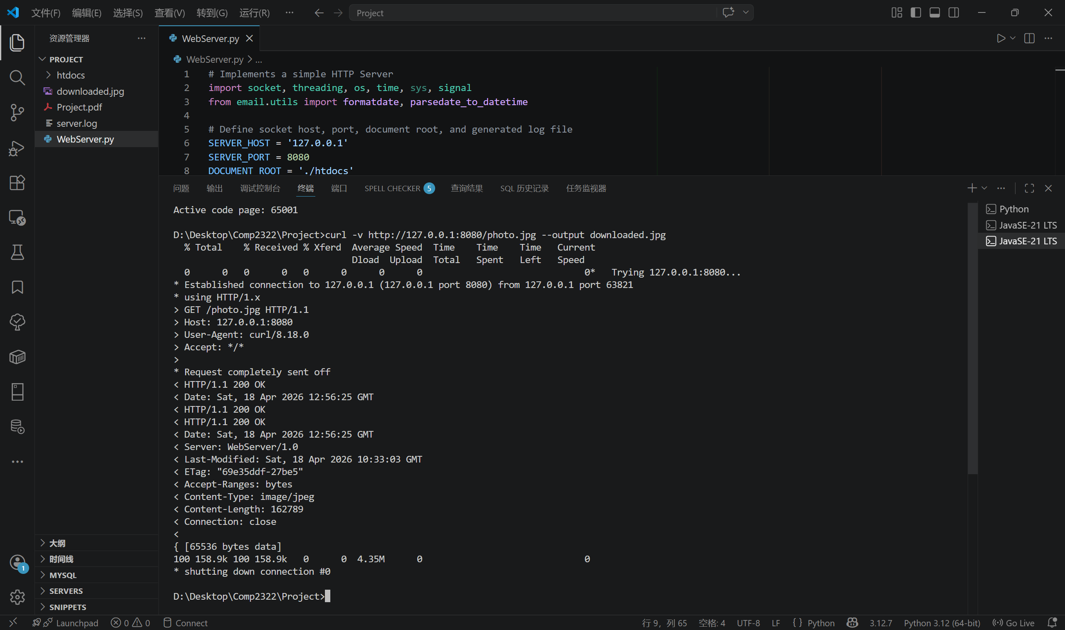
Image files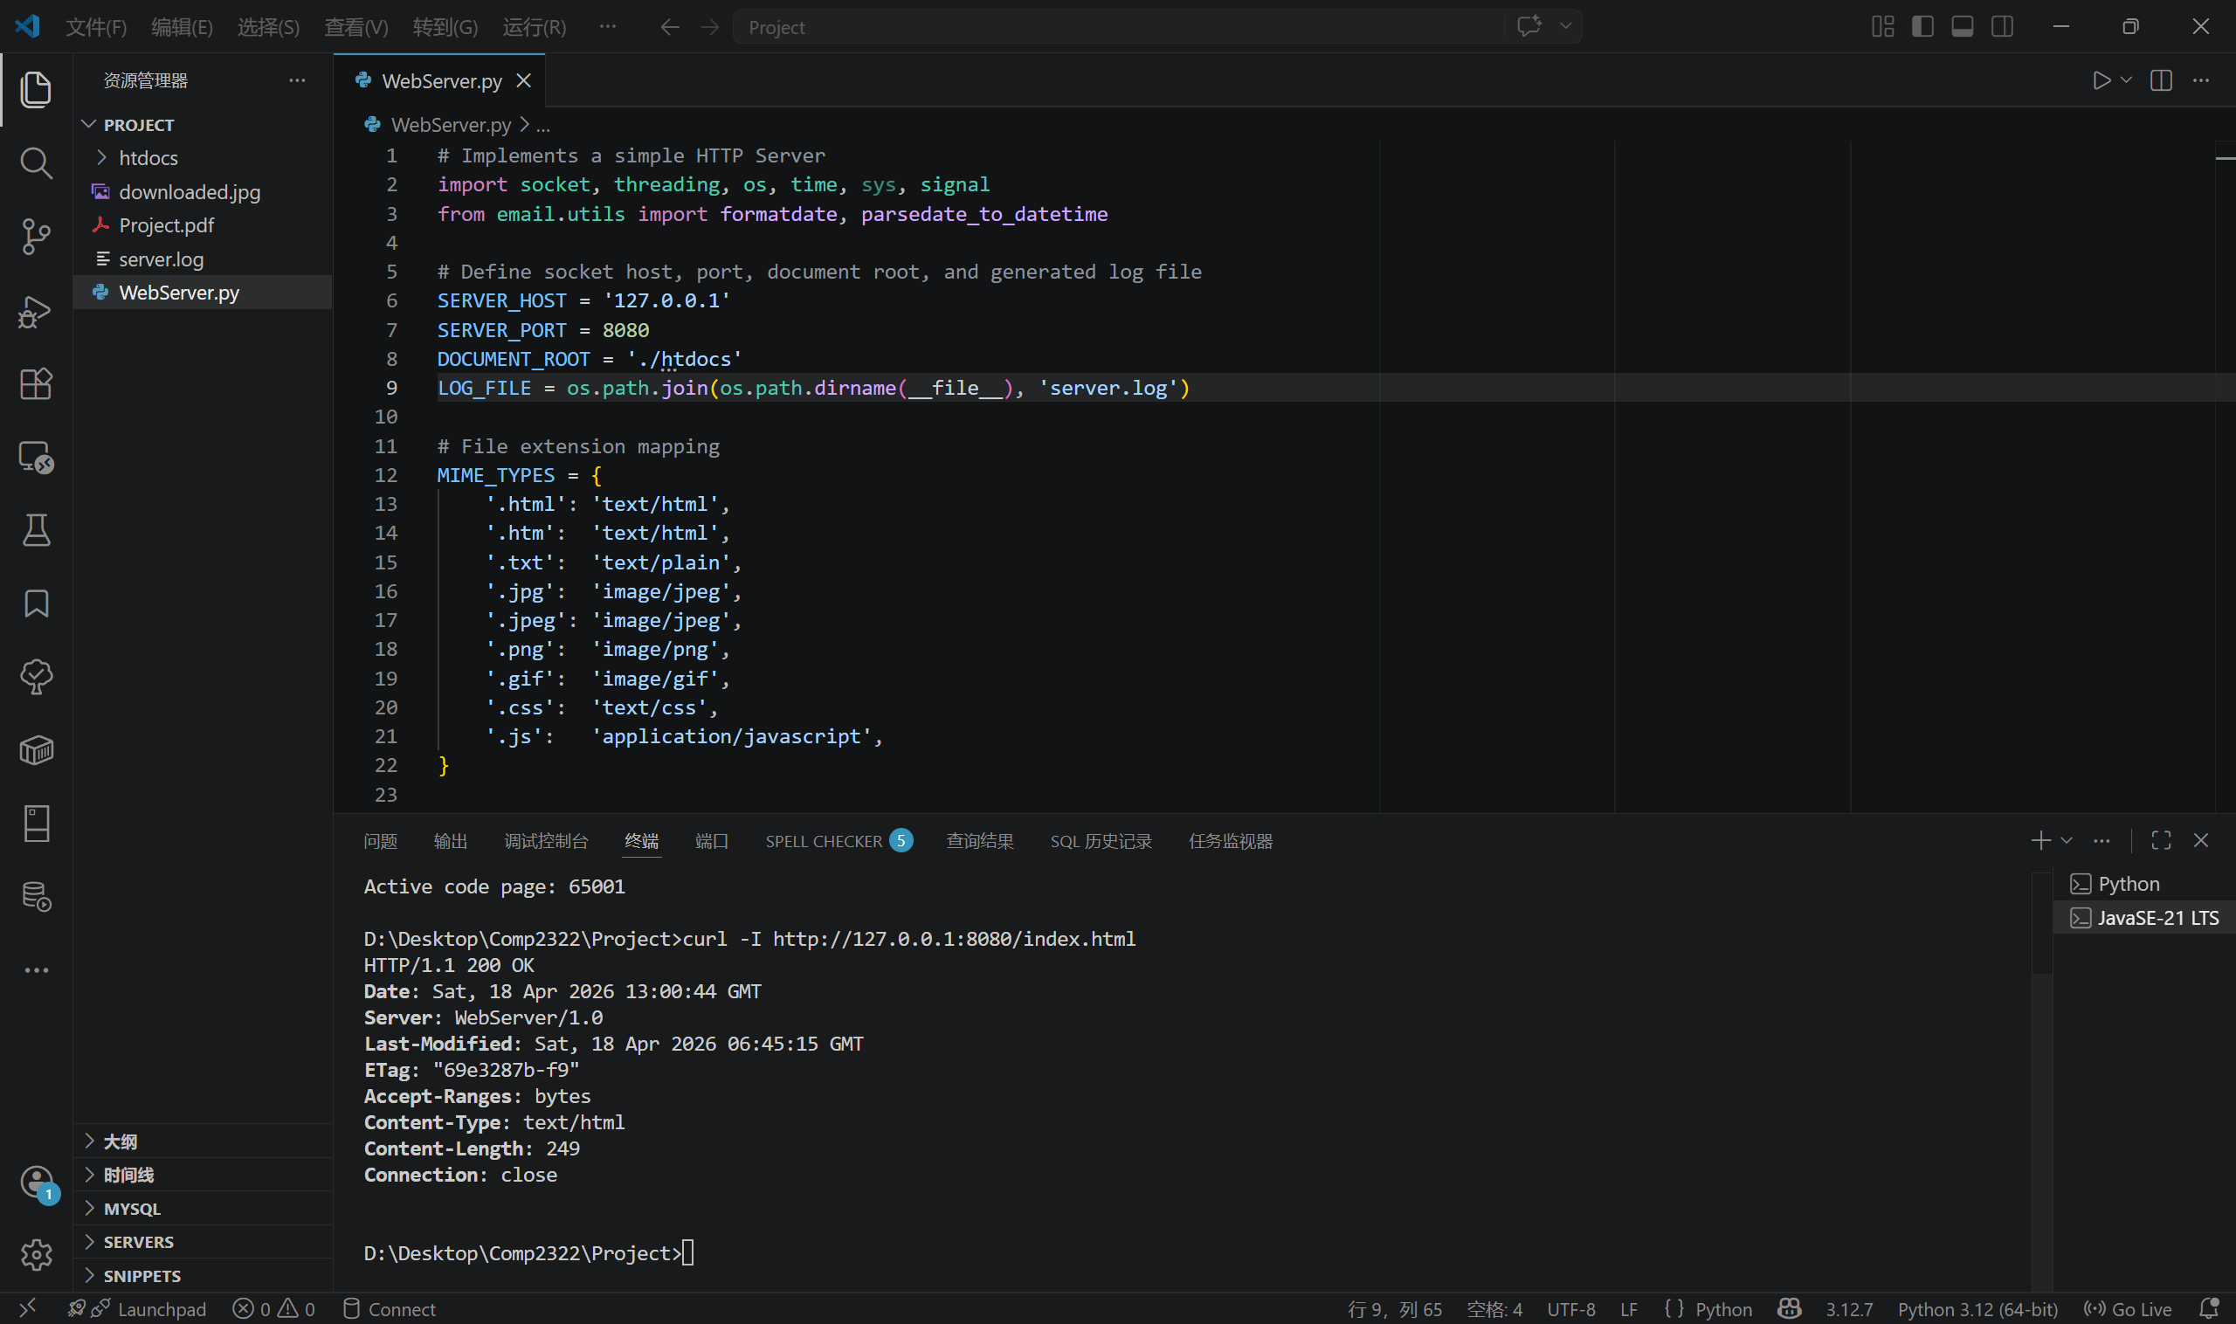
HEAD request type
- 400 Bad Request, 403 Forbidden, 404 Not Found, 304 Not Modified (Last-Modified and If-Modified-Since)
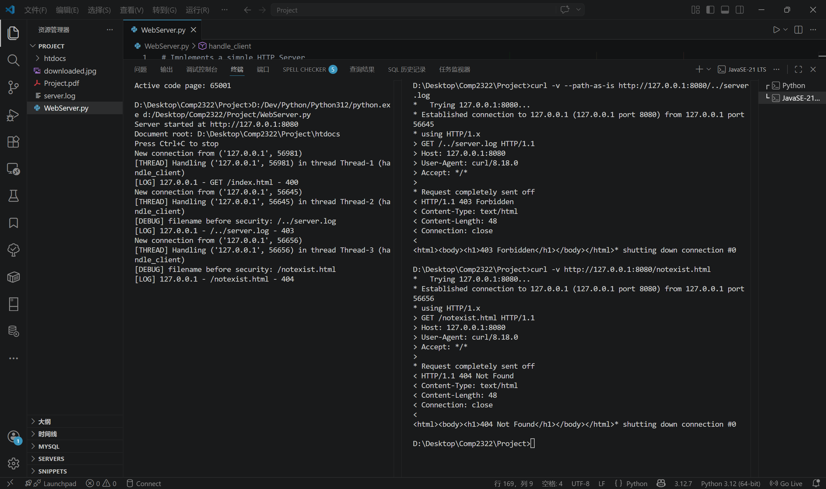
400, 403, 404
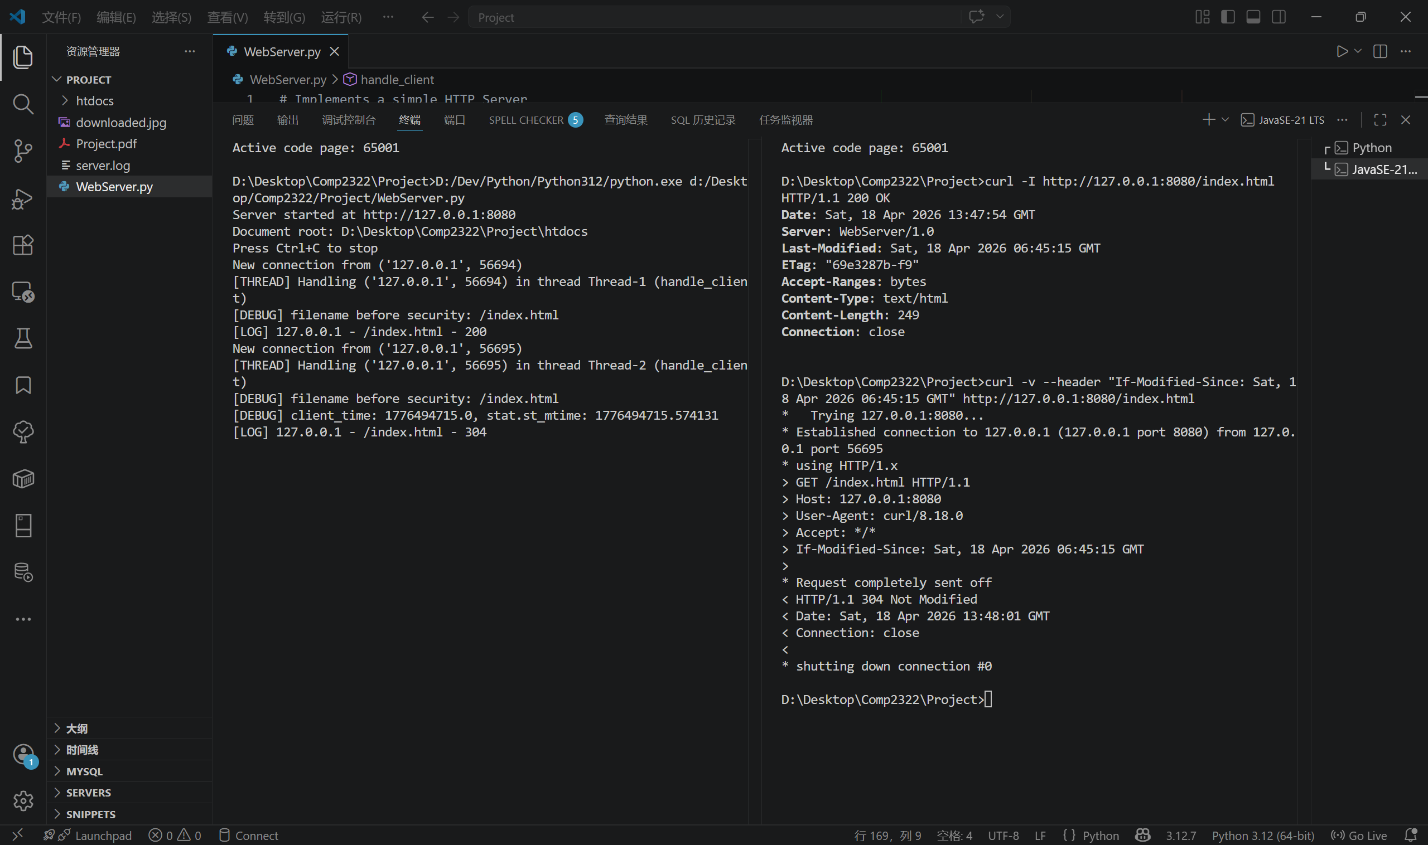
304 Not Modified 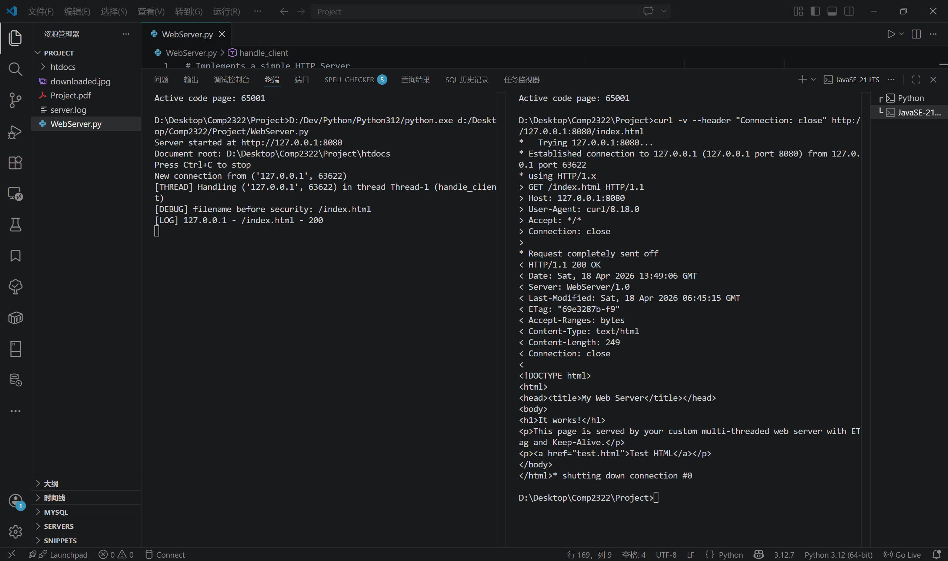
Close connection
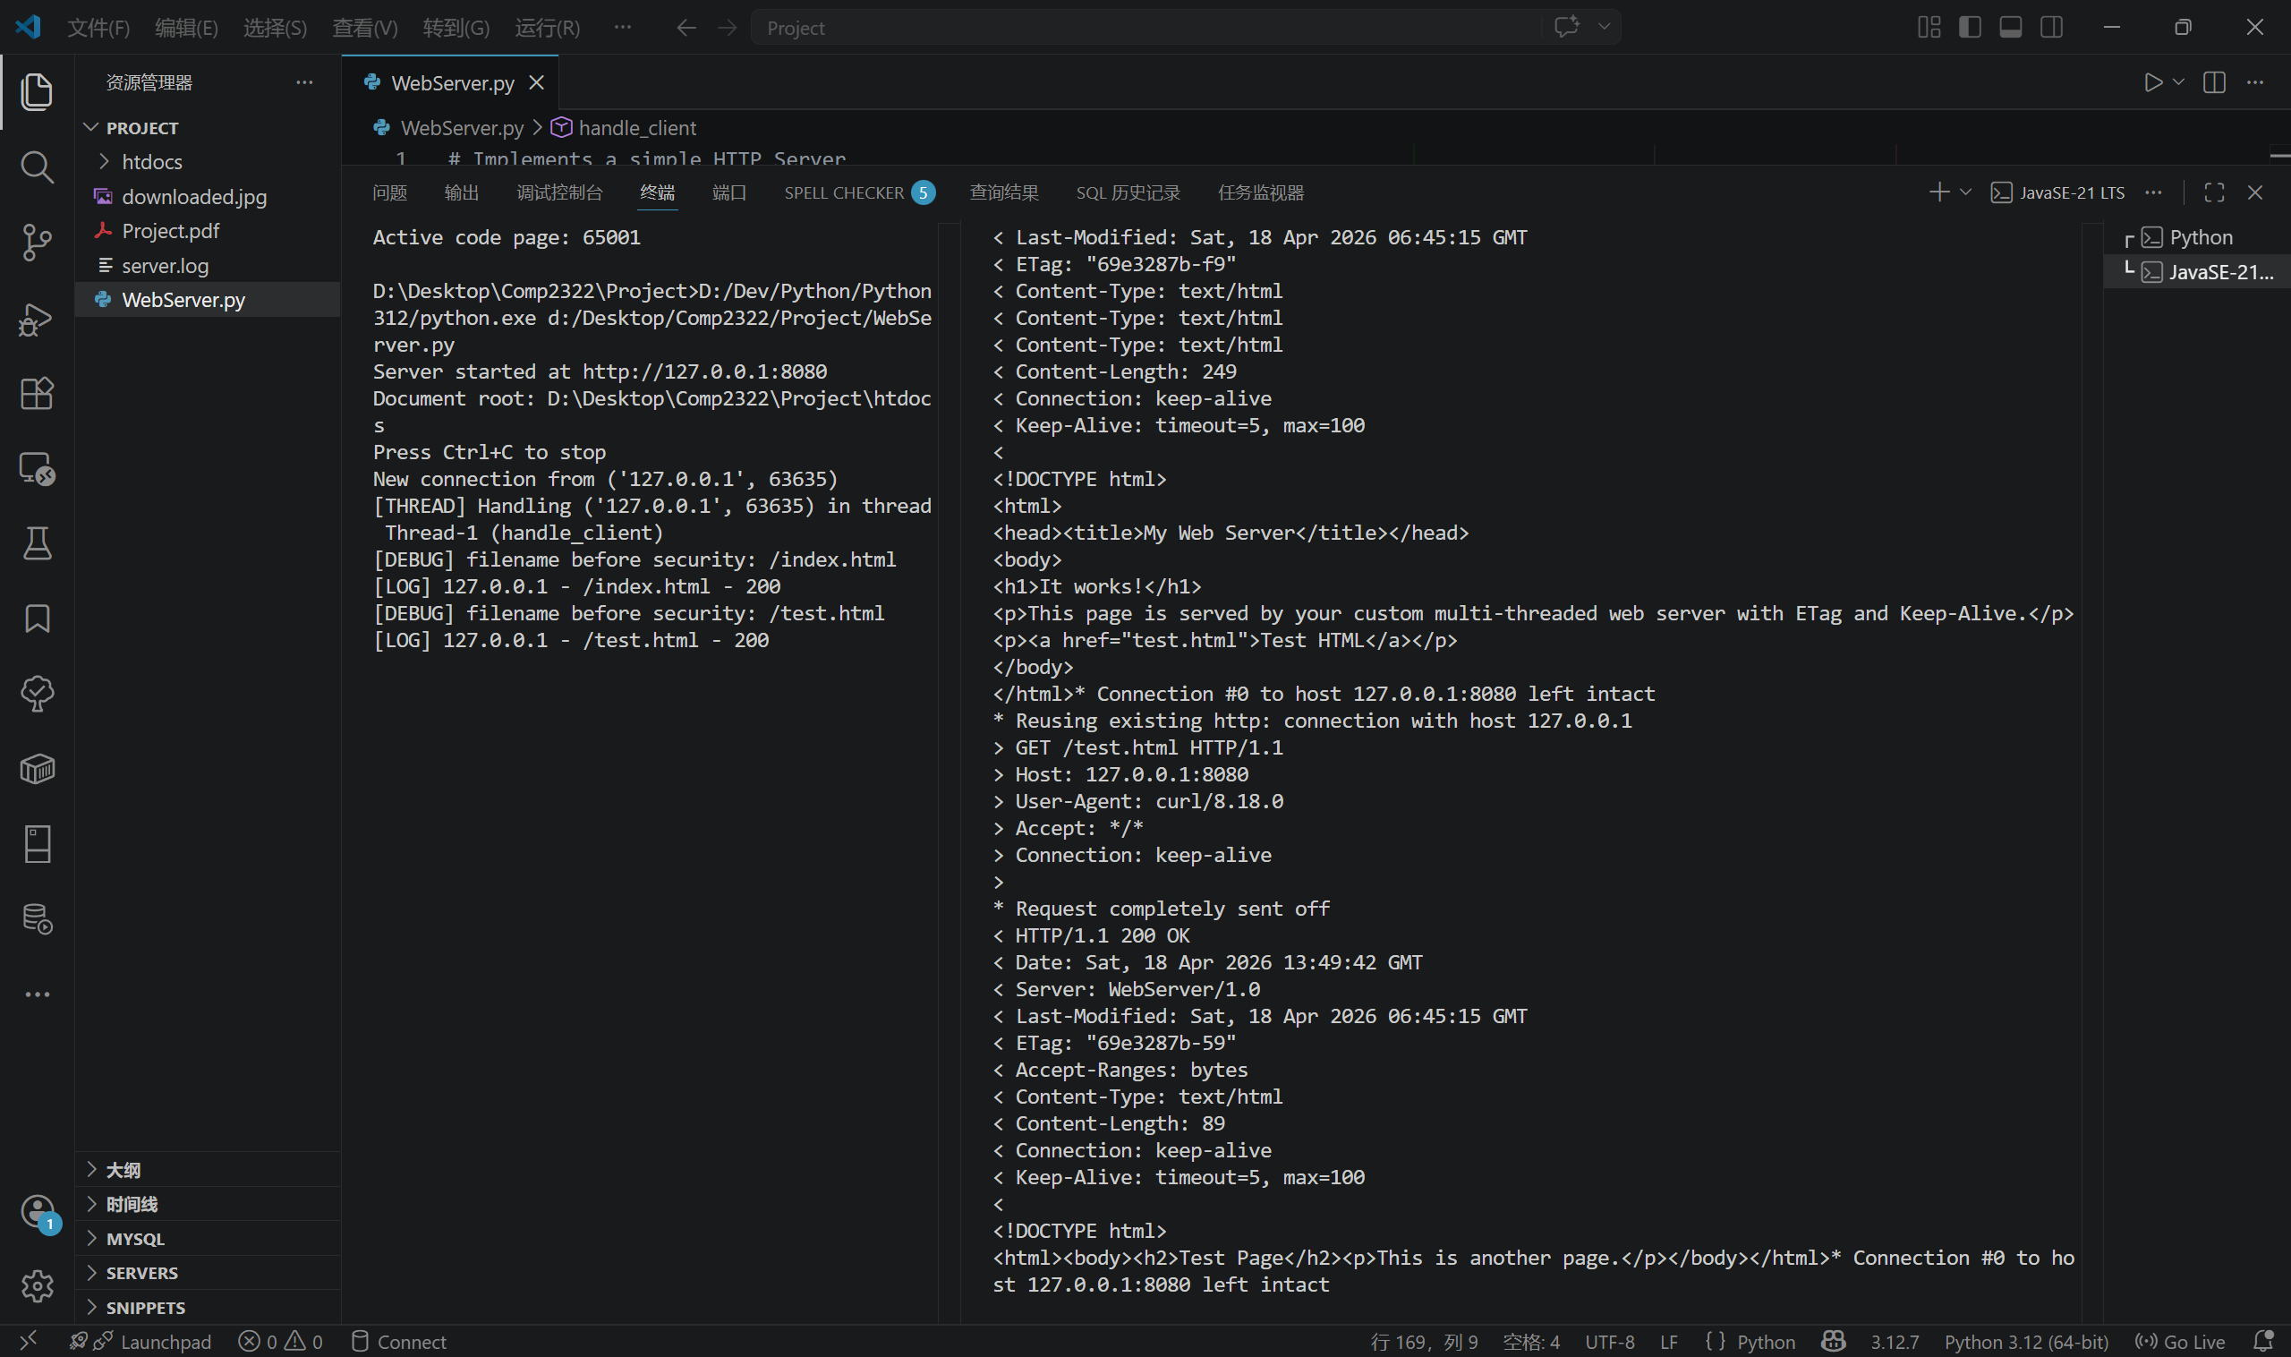
Keep-alive connection

- Log file
- 127.0.0.1 - - [2026-04-18 20:55:58] "/index.html" 200
- 127.0.0.1 - - [2026-04-18 20:56:25] "/photo.jpg" 200
- 127.0.0.1 - - [2026-04-18 21:00:44] "/index.html" 200
- 127.0.0.1 - - [2026-04-18 21:45:06] "GET /index.html" 400
- 127.0.0.1 - - [2026-04-18 21:46:13] "/../server.log" 403
- 127.0.0.1 - - [2026-04-18 21:46:31] "/notexist.html" 404
- 127.0.0.1 - - [2026-04-18 21:47:54] "/index.html" 200
- 127.0.0.1 - - [2026-04-18 21:48:01] "/index.html" 304
- 127.0.0.1 - - [2026-04-18 21:49:06] "/index.html" 200
- 127.0.0.1 - - [2026-04-18 21:49:42] "/index.html" 200
- 127.0.0.1 - - [2026-04-18 21:49:42] "/test.html" 200

